

BOOKIE – ebook system
Software Requirement Specification

– Hanoi, September 2022 –
Contents
I. Overview 3
1. Introduction 3
2. System Functions 4
3. Common Requirements 6
II. Functional Requirements 7
1. Home 7
2. User register 7
3. Forget Password 7
4. Logout 7
5. Login 7
6. View profile (Admin) 7
7. Update profile (Admin) 7
8. View list of books 7
9. View book’s description 7
10. View profile (Customers) 7
11. Update profile (Customers) 7
12. View security status 7
13. Change password 7
14. Comment 7
15. Rate book 7
16. Add to Favourite 7
17. Report Book 7
18. View/Update/Disable Book 7
19. View/Update/Delete Table of Contents 7
20. Access Level 7
21. View List User 7
22. Users Management 7
23. Wallet 7
24. Payment 7
25. Purchase a book 7
26. Reading interface 7
27. Pre-reading 7
28. Table of Contents 7
29.

I. Overview

1. Introduction
The Bookie – eBook System is a new web system that replaces the current library and all kind of it. Nowadays, people are getting more busy and lazy. They don’t have enough time or don’t want to go to the library to find a book or a shop to buy one. The system is expected to prevent the dead of knowledge come from books. Bookie want to create a brand new online-library that people can have access anytime, anywhere.
Main users:
- Administrators
- Customers: Normal person and authors
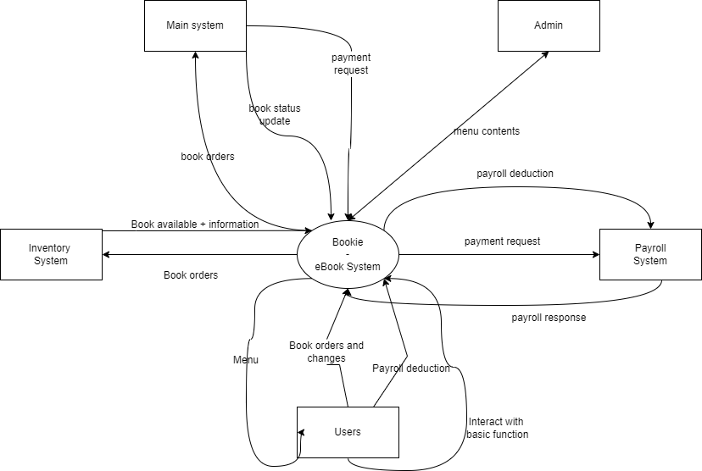

2. System Functions

a. Screen Flow
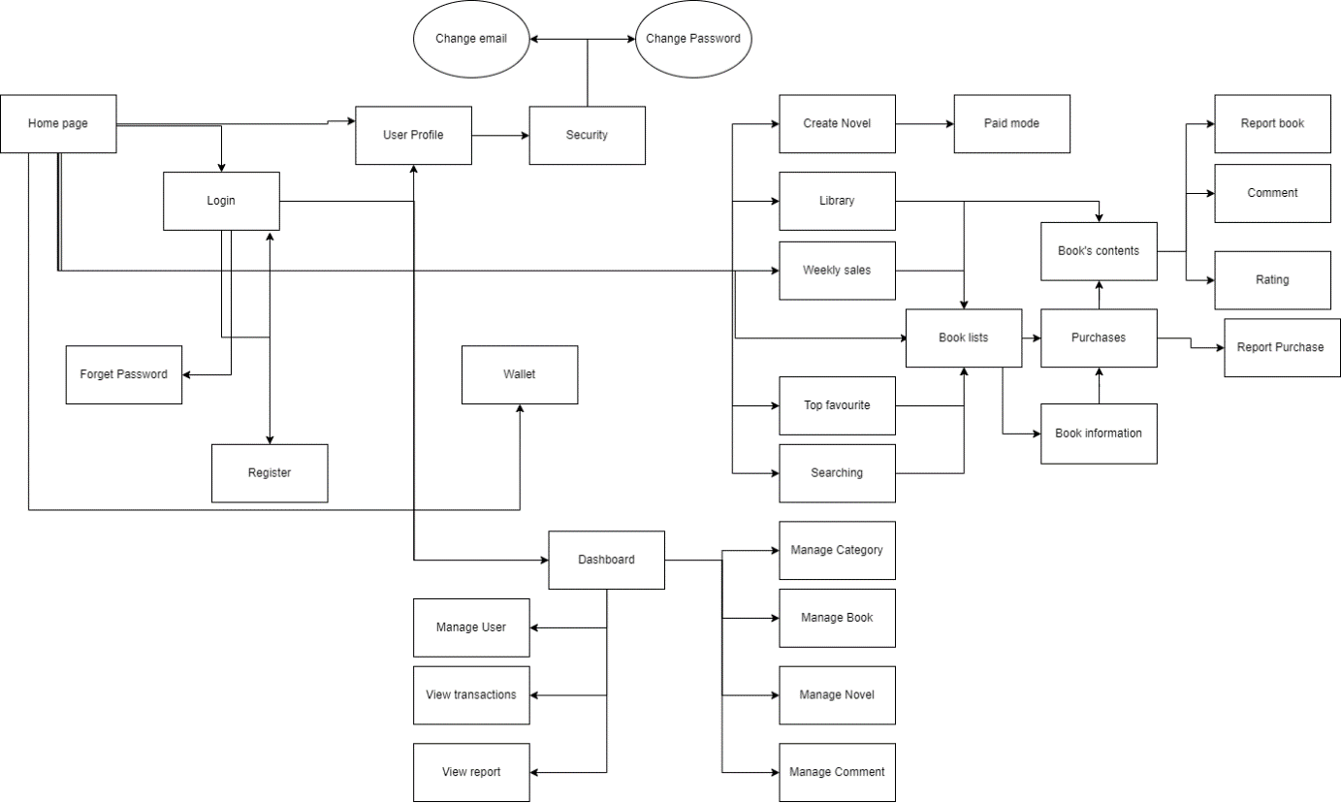

b. Screen Details
# | Feature | Screen | Description
1 | Common | Home Page | Default screen where all users can visit. There has information of system, contact of developer. The site can lead to login page and register page
2 | Common | User Register | Screen where users can create new account with personal information. Click Submit to submit new account
3 | Common | Login | Screen where the user logs into the system with the registered account. If the account or password is wrong, the system will notify the user
4 | Common | Change Password | Allow users who want to change their password account
5 | Common | User Profile | Display information about the user who is logged in to the system
6 | Admin | Dashboard | Display the dashboard that helps administrator manage the system.
7 | Common | Forgot Password | Allow user to reset password using registered email in case user forgot password
8 | Customers | Top Favourite | Display books having the most users adding to favour
9 | Customers | Weekly sales | Display books chosen with special discount weekly
10 | Customers | Book List | Display all books/novels
11 | Customers | View Book’s Information | Display information about name, authors, category, description, price, index… of the book
12 | Customers | Library | Display all books/novels customers purchase
13 | Customers | Wallet | Display balance in customer’s wallet
14 | Customers | Purchase | Allow customers to purchase a book/chapter with their wallet
15 | Customers | Read content | Allow customers to read the book/novel they purchased
16 | Customers | Comment | Allow customers to write their comment in book’s section
17 | Customers | Rating | Allow customers to rate a book/novel on a 5-star scale
18 | Customers | Searching | Allow customers to search for specific book by enter key words
19 | Customers | Report a purchase | Allow customers to report defective work or problematic transactions to request a refund/exchange
20 | Customers | Report a book | Allow customers to report a book that violates the community standards
21 | Customers | Create an Original Work | Allow authors to write and post their own work (must satisfy special rules for self-work)
22 | Customers | Paid mode | Allow authors to open the charge for their work
23 | Admin | Manage Category | Allow admins who want to add, edit and delete category of books
24 | Admin | Manage Book | Allow admins who want to add, edit and delete book’s information
25 | Admin | Manage OW | Allow admins who want to add, edit and delete user’s OW
26 | Admin | Manage Comment | Allow admins who want to view and delete if there are any inappropriate/offensive comments
27 | Admin | Manage User | Allow admins who want to up user to admin or disable any excessive user
28 | Admin | View transactions | Display all purchase in the system
29 | Admin | View reports | Allow admins who want to receive and handle any report by users
30 | Common | Change email | Allow users who want to change their email

c. User Authorization
Screen | Admin | Staff | Customers
Home Page | X | X | X
User Register | X | X | X
Customers Login | X | X | X
Admin Login | X | X
User Profile | X |  | X
Admin Screen | X | X
Forgot Password | X | X | X
Top Favourite | X | X | X
Weekly sales | X | X | X
Book List | X | X | X
View Book’s Information | X | X | X
Library | X | X | X
Wallet |  |  | X
Purchase | X | X | X
Read content | X | X | X
Comment | X | X | X
Rating | X | X | X
Searching | X | X | X
Report a purchase |  |  | X
Report a book |  |  | X
Create an OW |  |  | X
Paid mode |  |  | X
Manage Category | X | X
Manage Book | X | X
Manage OW | X | X
Manage Comment | X | X
Manage User | X | X
Change email | X | X | X
Change Access Level | X | X
Promote to Staff | X
In which:
- Admin: The manager of the organisation, has access to all system functions, decides every access to the system.
- Staff: The presentative of admin, who has the right to manage the system
- Customers: People who want to read book, novels and do the simple function of an eBook system. They can also be an author to write their own books, novels to make money

d. Non-Screen Functions
# | Feature | System Function | Description
1 | Common | User Authorization | Implement the authorization mechanism into the system. Using both front end and back end code to prevent users from accessing links without proper role.

3. Common Requirements

II. Functional Requirements

1. Home
- Function trigger: when user visits the page or when they click on the logo.
- Function description:
  - Actor: Users and Guests
  - Purpose: Landing page for all users
  - Interface:
+ A logo can access Homepage
+A fixed Menu collapsed
+ A introduction slide show
+A quote about book
+ Photos of featured product
+ Highlight/latest blogs
+ Contact interface
- Screen Layout:
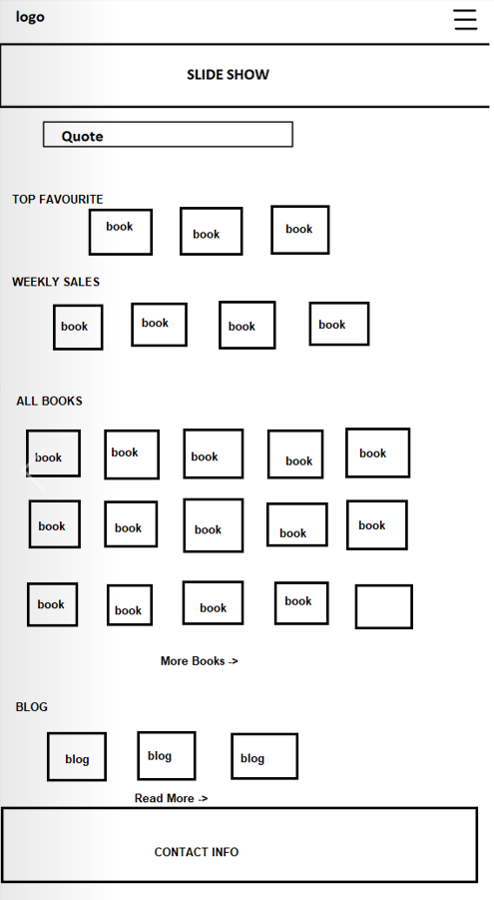
- Function Detail: When access website, user can see overview of page. The fixed Menu when open can see all the options that mention in Logout function. Slides Show part contains 3 pictures. Clicking on “See more” or “Read more”, user can see all of books or blogs. The contact carry information to connect to Administrators.

2. User register
- Function trigger: User clicks the “Sign Up” on Log In display.
- Function description:
  - Actor: Guests
- Interface:
  - 7 fields that users have to fill in all: Email, Username, Password. Phone, Full Name in the text style, Gender in option style and Birthday in date style.
  - 1 link head back to the Login screen
- Screen Layout
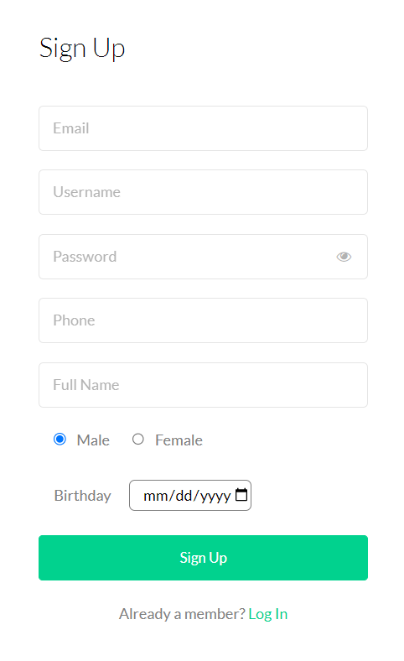

- Function Detail:
  - All fields must be filled up with data
  - Email and phone must be unique
  - Phone: start with 0, have 10 letters of number
  - Email: must have @
  - After click “Sign Up”, if all fields are validated and account created successfully, Users will head back to the Login Screen
  - After click “Log In”, users will head back to the Login Screen

3. Forget Password
- Function trigger: When users click the “Forget Password” in the Login Screen
- Function description:
  - Actor: Users
  - Purpose: Help users find back their account by receive a new password sent into the email they provided when they created account.
  - Interface
+ input for email
+ 1 button to submit
+ 1 link to head back Login Screen
- Screen Layout:
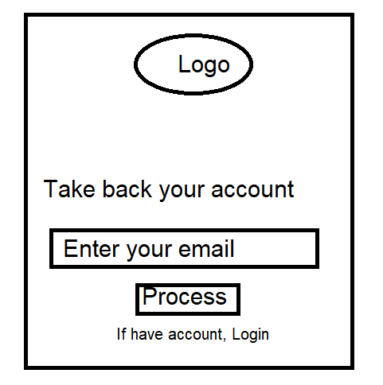
- Function details:
  - Users have to fill the form with an existing email that he/she had registered while they created the account
  - When he/she clicks the “Process” button, system will check the email they entered, check if it is existing in the database or not
  - If it is a valid email, a new password will be sent to that email

4. Logout
- Function trigger: In Home Page has been Logged In, user clicks on Menu and then selects Logout.
- Function description:
  - Actor: Users (include administrators and customers)
  - Purpose: to end access to a website
- Screen Layout:
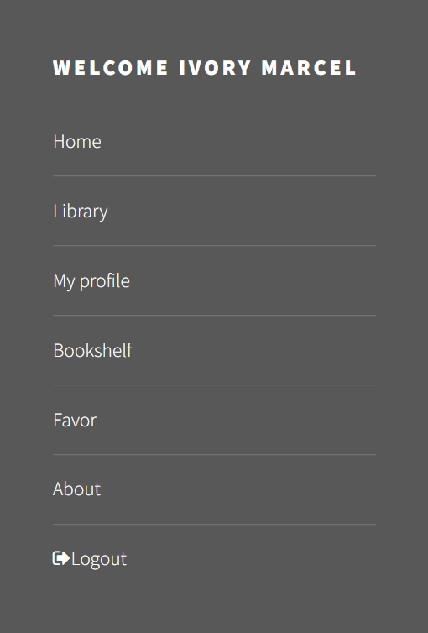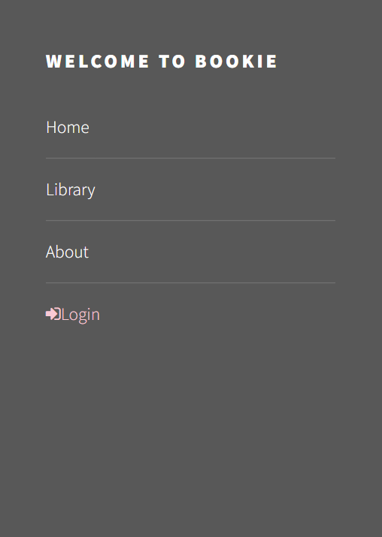
Before Logout After Logout
- Function Detail: When user click to “Logout” option, its session will be destroyed. User will be directed to Homepage.

5. Login
- Function trigger: Click “Login” on pop up home page
- Function description:
  - Actor: Admin, User
  - Users that have not yet registered cannot log in. They must contact the education unit to create a new account.
- Function interface:
  - 2 input text fields
  - 1 button “Sign In” to head into the home page of the system
  - 1 button “forget password” to head the users to the take back account screen
  - 1 button “sign up” to help users create their accounts
- Function detail:
  - Users shall login to the system by using the username and password which is registered.
  - Users shall be able to use system functionalities and be directed to the formal screen after successful login.
  - The Users will receive “errors” to the login screen if the username or password is invalid.
- Screen layout:
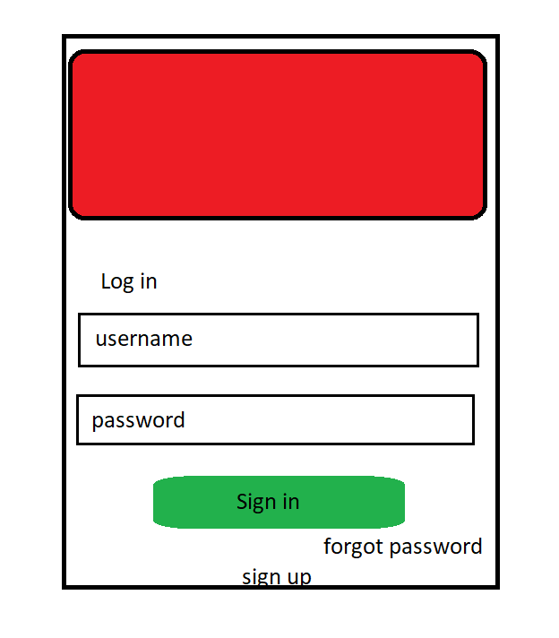

6. View profile (Admin)
- Function trigger: Dash board page click “Profile”
- Function description:
  - Actor: Admin
  - Admin can view account’s profile
- Function interface:
  - The profile of Admin account will display on profile screen
  - Admin can view all those details
  - Screen layout:
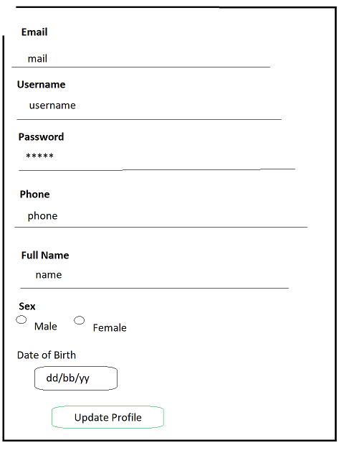

7. Update profile (Admin)
- Function trigger: From Profile page
- Function description:
  - Actor: Admin
  - Admin can update profile need to
- Function detail:
  - There is a list of data of admin account.
  - Admin can check and rewrite what they want
  - Click the “Update” button to save the new details
  - Notice updating successfully
● Screen layout:

8. View list of books
- Function trigger: When admin click the “Book Manager” in the Admin Panel
- Function description:
  - Actor: Customers
  - Interface
+ 1 list of Categories for users to choose
+ List books by category or all kind of books
- Screen Layout:
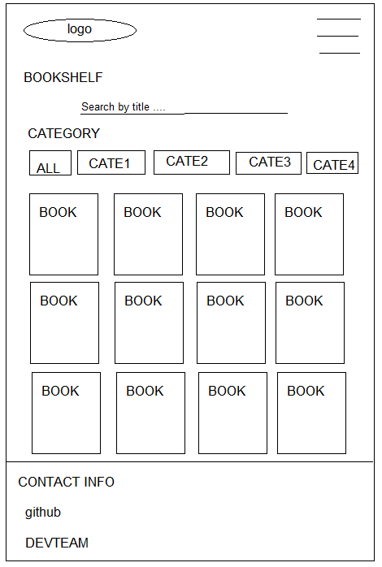
- Function details:
- All Categories can be chosen to search book by category
- If click to a Book, users can see the Book details

9. View book’s description
- Function trigger: When users click button in Edit column in Book Manager page
- Function description:
  - Actor: Users
  - Interface:
+ 1 button GET: send book to user’s carts where user can pay money to buy books
+ 1 button Add to Favourite: send this book to user’s favourite list
+ 1 button Report: help users report the book that violate the rules
+ 1 textbox: give space for user to type their comment
+ 1 button to help user post their comments
+ 1 list of check box that represent as star: help user vote/rate this book
- Screen Layout:
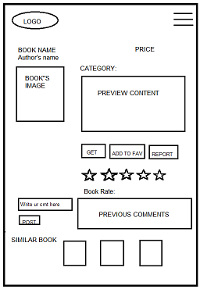

10. View profile (Customers)
- Function trigger: This use case starts when an user click on navigation bar button on top right of website and click “My profile”.
- Function description:
- Role: Customers
- Screen layout:
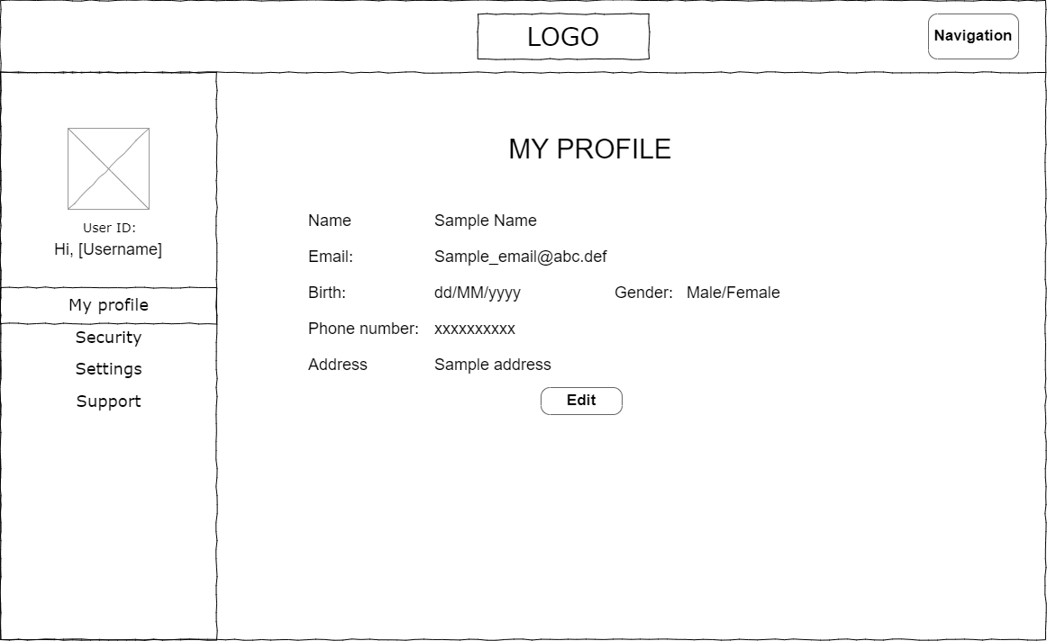
- Function detail:
  - System displays user’s profile include his user id, username, name, date of birth, gender, email, phone, address.
  - From this screen, user can choose to edit his profile.

11. Update profile (Customers)
- Function trigger: This use case starts when user click on “Edit” button in view profile screen.
- Function description:
  - Role: Customers
  - Purpose: Update user’s profile
  - Interface:
    - 2 input text boxes for to enter name, and address
    - 1 input date to enter date of birth
    - 1 input number to enter phone number
    - 2 input radiant to choose gender
    - 2 button “Cancel” and “Save”

- Function layout:
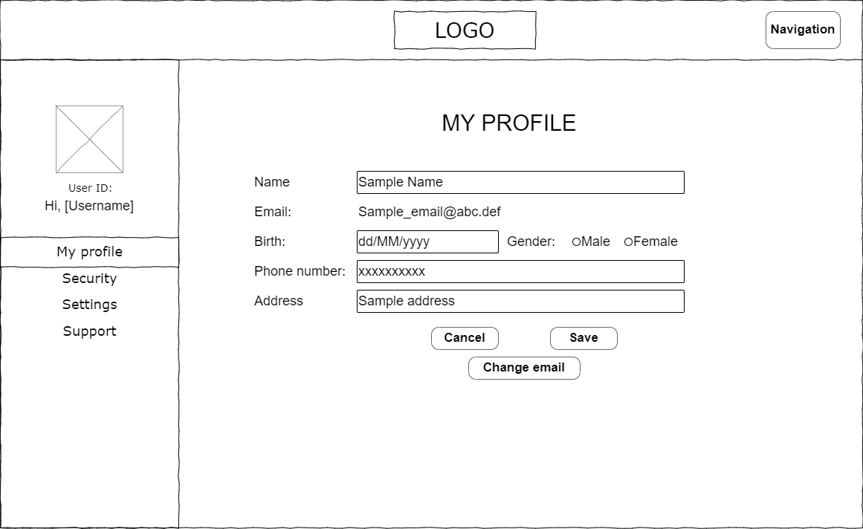
- Function detail:
  - The user can see his current information and change them (except user id, username and email). All fields cannot be empty except address.
  - Phone number must be a string of 10 digits.
  - Name only have alphabetic characters and space characters. Name cannot be longer than 40 characters.
  - User can choose “Save” to save new information or choose “Cancel” to back to view profile screen without any change.

12. View security status
- Function trigger: This use case starts when user click on “Security” tab in left sidebar.
- Function description:
  - Role: User
  - Purpose: View account’s security
- Function layout:
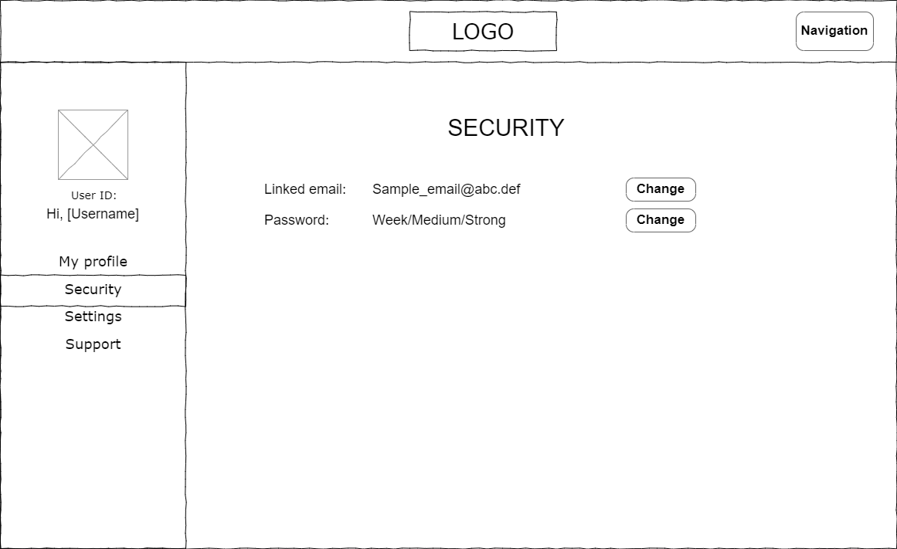
- Function detail:
  - The user can see current email and password level of account.
  - Password level show how strong current password is:
    - Password just have number or alphabetic character, password level is week.
    - Password have both alphabetic characters and numbers, password level is medium.
    - Password have alphabetic characters, number and special character, password level is strong.

13. Change password
- Function trigger: This use case starts when user click on “Change” beside password level in security screen.
- Function description:
  - Role: User
  - Purpose: Change password
  - Interface:
    - 3 text boxes to enter password, new password and confirm password
    - 2 button “Cancel” or “Confirm”
- Function layout:
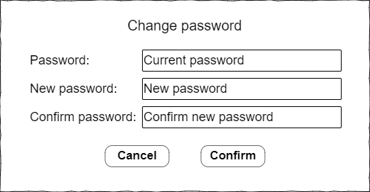

- Function detail:
- When user choose to change password, this pop-up will open. User enter current password to authorize this action, then enter new password 2 times.
- Then choose confirm to change password.
- If user does not want to change password, click “Cancel”.
- User cannot confirm if current password is wrong, or confirm password does not match with new password, or new password is invalid. New password is invalid when:
+ It is empty.
+ Its length is less than 6 character or more than 32 characters.
+ It starts with a space.

14. Comment
- Function trigger: When user write their comment in the text box and click Comment in the Book-detail page
- Function description:
  - Role: Users
  - Purpose: let users write their feeling about the book
  - Interface:
+ 1 text box for users to write their comments
+ 1 button to submit their comment
+ 1 textbox to display the previous comments
- Function Layout:
- Function Detail:
  - Text box “Write your comment here” can accept any kind of data (String)
  - When user click the button “POST”, their comment will be added to the textbox in the right, the page is refresh at the same time.

15. Rate book
- Function trigger: When user click on the Star
- Function description:
- Role: Users
- Purpose: Let user rate this book
- Interface:
+ 5 stars that represent the rating from 1 to 5
+ 1 button to submit rate
- Function Layout:
- Function Detail: This function will not be shown unless users log in into the system

16. Add to Favourite
- Function trigger: When user click the Add to Favourite button in the Book detail page
- Function description:
- Role: Users
- Purpose: Send this book to user Favourite’s book list
- Function Layout:
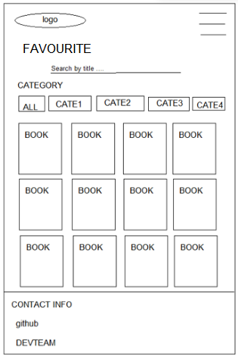
- Function Detail:

17. Report Book
- Function trigger: When user click the Report button in the Book detail page
- Function description
- Roles: Users
- Purpose: let user send report to admin that the book violated the community’s rules
- Function Layout:
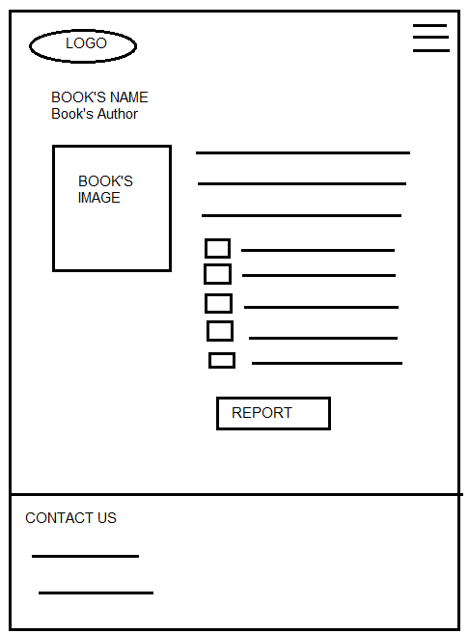
- Function Detail:
  - The screen displays the book name, author, image
  - The checkboxes that store options for user can check it and click the Report button to send it to the admin

18. View/Update/Disable Book
- Function trigger: When users click the “Book Management” in the Management Panel
- Function description:
- Actor: Admin, Staff
- Admin/Staff can add new books or disable old ones. It is also possible to edit or update the information of the student.
- Function detail:
- Click on Add Book button to add new books, there will be information text boxes which are needed to add a book.
- If you want to disable the book, click button at Disable column at the end of that row
- If you want to edit the information of the book, click button at Update column
- Screen Layout:
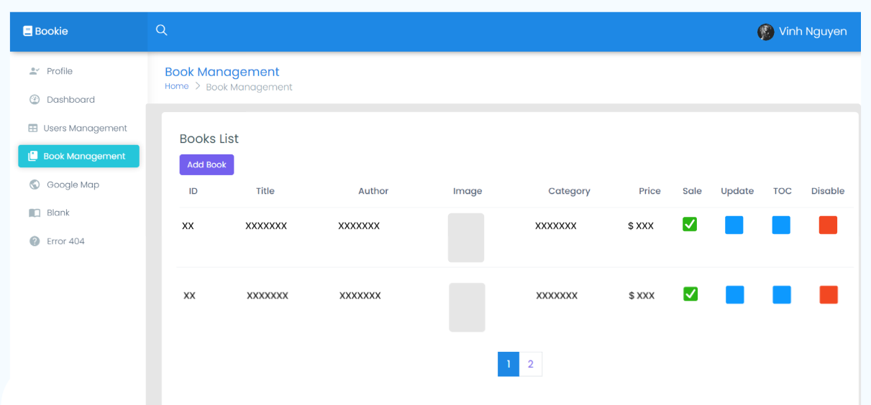
    - Button: Book Management, Add Book, Update, TOC (Tables of Contents), Disable
    - Table includes Book ID, Title, Author, Image, Category, Price, Sale Status
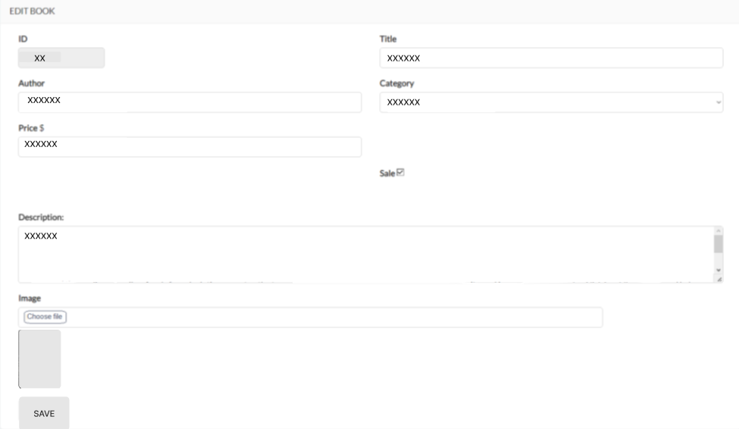
    - Button: Save
    - Inputs field for Book’s information

19. View/Update/Delete Table of Contents
- Function trigger: When users click button in TOC column in Book Management page
- Function description:
- Actor: Admin/Staff
- Admin/Staff can add new volumes, new chapters or delete old ones. It is also possible to edit or update the information of the volumes or the chapters
- Function detail:
- Click on Add Volume to add new volumes, there will be information text boxes which are needed to add a volume
- To arrange the order of the book’s volumes, click on Arrange Volume
- To delete the volume, click at the end of each volume row, select Delete
- To edit the volume, do the same as above and select Edit
- Click on Add Chapter to add new chapters, there will be information text boxes which are needed to add a chapter, including chapter’s contents
- To arrange the order of the volume’s chapters, click at the end of their volume row, and select Arrange
- To delete the chapter, click at the end of each chapter row, select Delete
- To edit the chapter, do the same as above and select Edit
- Screen Layout:
    - Button: Add Volume, Arrange Volume, Edit Volume, Delete Volume, Save
    - Input fields for Volume’s information
    - Button: Add Chapter, Edit Chapter, Delete Chapter, Arrange Chapter
    - Input fields for Chapter’s information

20. Access Level
- Function trigger: Login
- Function description
  - Roles: Admins, Users
  - Purpose: locate role for the account
- Function Detail:
  - Depend on the level of account user can login or not
  - Also from 4 or upper is for admin and super admin

21. View List User
- Function trigger: When admin click Users Management title
- Function description
- Roles: Admin
- Purpose: let admin can see the list of users account below
- Function Detail:
- The screen will display the users account detail
- Depend on admin’s level, it will display all the accounts which have the lower level

- Screen Layout: 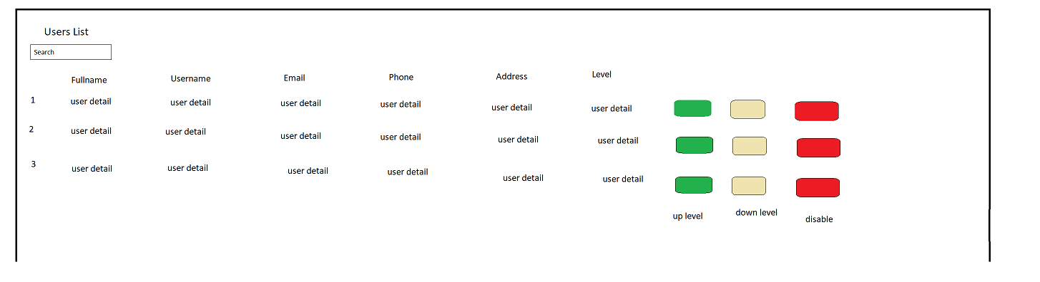

22. Users Management
- Function trigger: When admin click any button, title or input in search box
- Function description
- Roles: Admin
- Purpose: adjust and view the account’s details
- Function Detail:
- Admin can adjust the level of that account from: normal user to author or admin
- Admin can ban the account
- Admin can search, sort by each title

- Screen Layout:

23. Wallet
a. View
- Function trigger: This use case starts when user click on “Payment” on left side bar in profile screen.
- Function description:
  - Role: User
  - Purpose: View wallet’s balance
- Function layout:
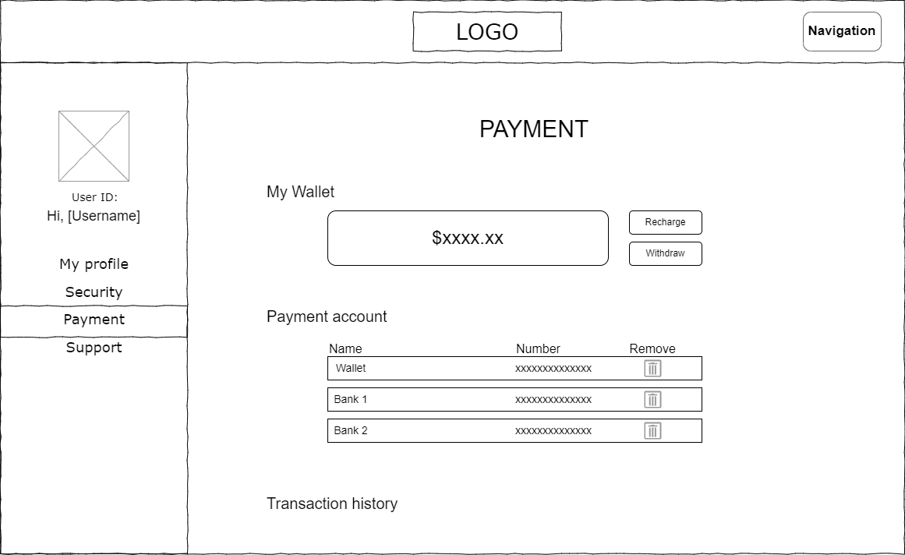
- Function detail:
  - Wallet’s balance will be hidden at start. User can click on eye icon to show or hide it.

b. Transaction history
- Function trigger: This use case starts when user click on “Payment” on left side bar in profile screen and scroll down.
- Function description:
  - Role: User
  - Purpose: View list of all transactions
- Function layout:
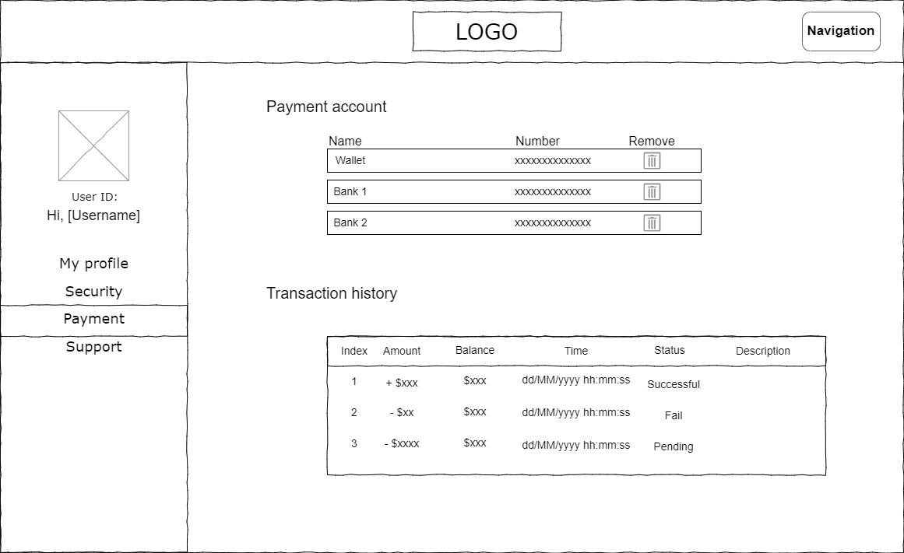
- Function detail:
- User can see list of all transaction he made
c. Recharge
- Function trigger: This use case starts when user click on “Recharge” at right of balance.
- Function description:
  - Role: User
  - Purpose: Recharge money from linked bank into wallet
  - Interface: Pop-up
+ 3 input field to enter amount, payment and password
+ 2 button to choose cancel or confirm
- Function layout:
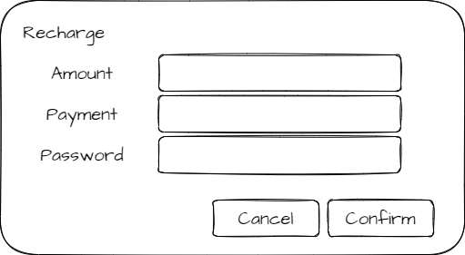
- Function detail:
- Amount to recharge cannot greater than balance in chosen payment.
- Password must match with current password of user.
- If user don’t want to recharge more, click cancel.
- If user certainly want to recharge, click confirm.

d. Withdraw
- Function trigger: This use case starts when user click on “Withdraw” at right of balance.
- Function description:
  - Role: User
  - Purpose: Withdraw money from wallet to linked bank
  - Interface: Pop-up
+ 3 input field to enter amount, payment and password
+ 2 button to choose cancel or confirm
- Function layout:
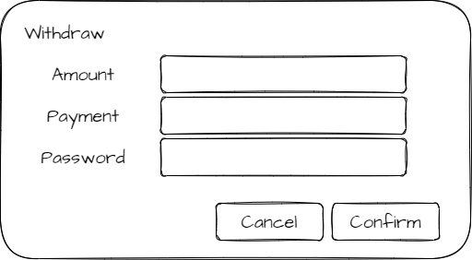
- Function detail:
- Amount to withdraw cannot greater than balance in wallet.
- Password must match with current password of user.
- If user don’t want to withdraw more, click cancel.
- If user certainly want to withdraw, click confirm.

24. Payment
a. Remove
- Function trigger: This use case starts when user click on Trash can icon at the right of payment method that user wants to remove
- Function description:
  - Role: User
  - Purpose: Remove a payment method
  - Interface: Popup
+ 1 input field to enter password
+ 2 buttons cancel and confirm
- Function layout:
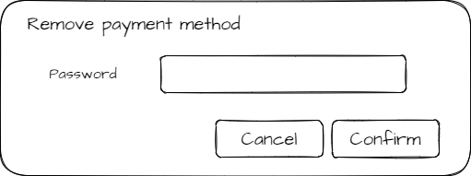
- Function detail:
- Password must match with current password of user.
- If user don’t want to remove this payment method more, click cancel.
  - If user certainly want to remove this payment method, click confirm.
  - User can not remove wallet
b. Add
- Function trigger: This use case starts when user click on “Add payment” button unber the payment method’s table
- Function description:
  - Role: User
  - Purpose: Add a payment method
  - Interface: Popup
+ 3 input field to enter account number, payment name, password
+ 2 buttons cancel and confirm
- Function layout:
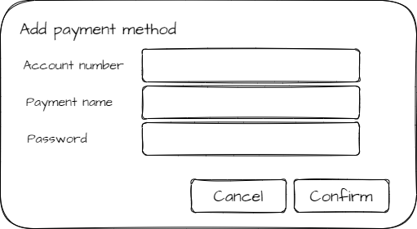
- Function detail:
- Account number is required.
- If there is no payment account have this number, not do anything.
- Password must match with current password of user.
- If user don’t want to add payment method more, click cancel.
- If user certainly want to add this payment method, click confirm.
- User can not remove wallet

25. Purchase a book
a. Remove
- Function trigger: This use case starts when user click on “Buy” in book detail screen
- Function description:
  - Role: User
  - Purpose: Remove a payment method
  - Interface: Popup
    - 1 input field to enter password
    - 2 buttons cancel and confirm
- Function layout:
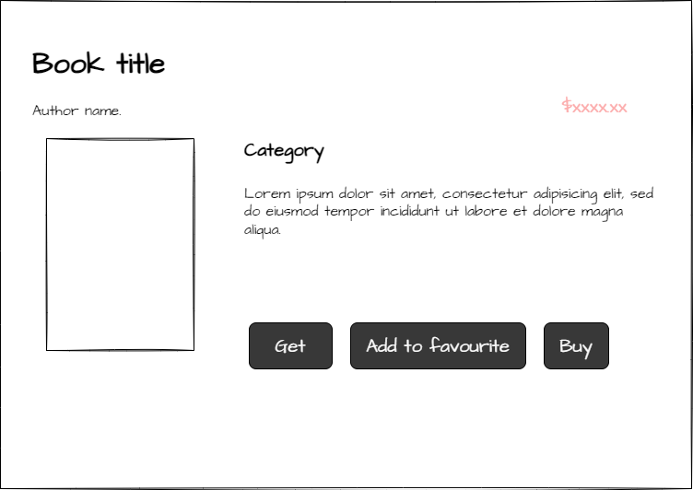
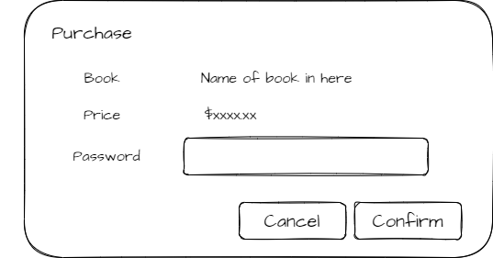
- Function detail:
- Password must match with current password of user.
- If user don’t want to buy this book more, click cancel.
- If user certainly want to buy this book, click confirm.
- Before buy this book, user should warrant that book’s price is not greater than balance in his wallet

26. Reading interface
- Function trigger: when user (has paid for the book) click on chapters
- Function description:
  - Actor: Users
  - Purpose: Setting interface for reading book
  - Interface:
+ A logo can access Homepage
+ A fixed Menu collapsed
+ A header of book’s name
+ A header of Chapter
+ Content of chapter
+ Contact interface
- Screen Layout:
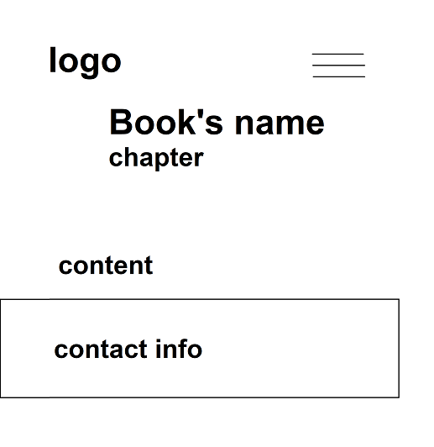

- Function details: After purchasing for books, user can read all chapters from Table of Contents. The book-reading page display content of the chapters that user choose. The contact carry information to connect to Administrators.

27. Pre-reading
- Function trigger: when user clicks on “Preread” button
- Function description:
  - Actor: Users
  - Purpose: Reading the brief chapter of book
  - Interface:
+ A logo can access Homepage
+ A fixed Menu collapsed
+ A header of book’s name
+ A header of Chapter
+ Content of chapter
+ Contact interface
- Screen Layout:

- Function details: Before purchasing book, user can read the first chapter before deciding to purchase or not.

28. Table of Contents
- Function trigger: After using purchase for a book successfully, the table of contents will be automatically displayed
- Function description:
  - Actor: Users
  - Purpose: Accessing chapters’ content for reading
  - Interface:
+ A header named “Table of contents”
+ All volumes’ name of books
+ All names of chapters of each volume
- Screen Layout:

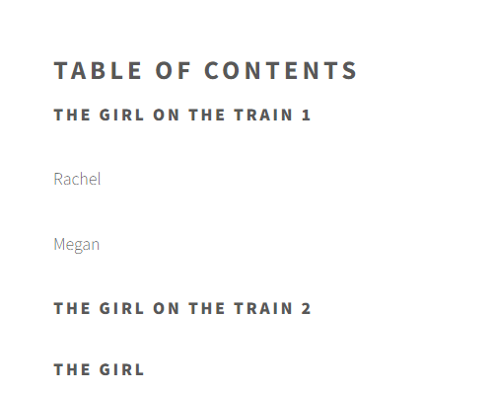
- Function details: The Table of Contents only be display after user purchase for book. When they click on Chapter’s name, it will redirect to book-reading interface. The book-reading page display content of the chapters that user has chosen.

29. Search Engine
- Function trigger: When user click on the Search button in Library and select the book’s category in Genre list
- Function description:
  - Actor: Users
  - Purpose: Let user search the book of their wants
  - Interface:
+ Page number in the nearby footage of the page: Click will send users to others pages of library
+ List of Category in buttons on the left
+ Search Engine: Search by title and Advanced Search

- Screen layout:
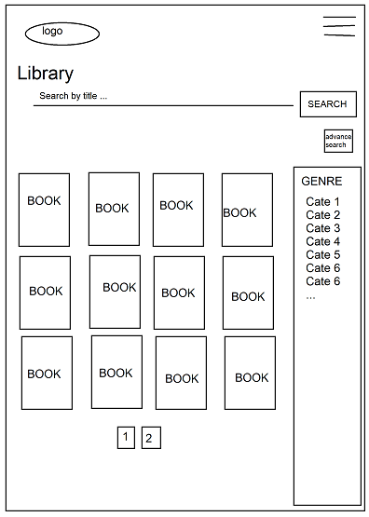
  - Advanced Search:
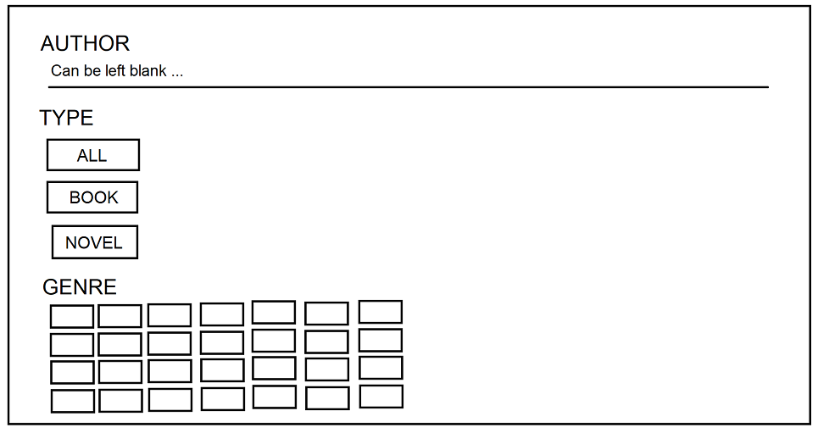

- Function detail:
  - Genre list in both outside and inside advanced search will show all the categories that have in the database
  - Genre Lists are checkbox, let user choose more than 1 category
  - When user click button “Search”, the system will return all the book/novel that meet the requirements in pages(paging)
  - In both advanced search and library interface will have textbox for user to enter title of the book (in the library interface) and enter author’s name (in advanced search)

30. Paging
- Function trigger: When users enter any kind of library in the website, click the page number in the near by footer of the page
- Function description:
  - Actors: User
  - Purpose: Split the collection of books into pages to make the library more succint
  - Interface:
+ Page number in the nearby footage of the page: Click will send users to others pages of library
+ List of Category in buttons on the left
+ Search Engine: Search by title and Advanced Search
- Screen layout:
- Function detail:
  - Each page will have 12 books
  - While users are in 1 page, that page’s number will have a difference color

31. Delete from Favourite
- Function trigger: When users click the “Delete Favourite” in the Book Detail Screen
- Function description:
  - Actor: Users
  - Purpose: Let users remove this book from their favourite collection
  - Interface:
+ 4 button: Get(Purchase book), Delete Favourite(Remove this book from Favourite), Report(Report this book), Post(Send the comment to this book)
+ 1 text input: where to let users enter the comment they want to
+ 5 radio button represent for 5 stars rating
- Screen Layout:
  - Before click “Delete Favourite”:
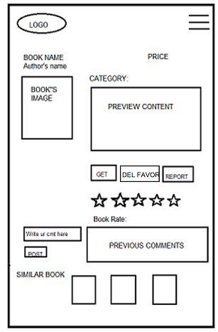
  - After click “Delete Favourite”:

32. View/Manage Novels
- Function trigger: When users click the “My Novels” in the User Profile screen
- Function description:
- Actor: Customer
- Customer can create his/her own novel or delete/disable old ones. It is also possible to edit or update the information of the novel.
- Function detail:
- Click on Create! button to create new novel, there will be information text boxes which are needed to add a novel.
- If you want to disable the novel, click button at Disable column at the end of that row
- If you want to edit the information of the novel, click button at Update column. In update screen, if the novel haven’t been bought by any customer, Delete button can be displayed and entered to be permanently deleted.
- Screen Layout:
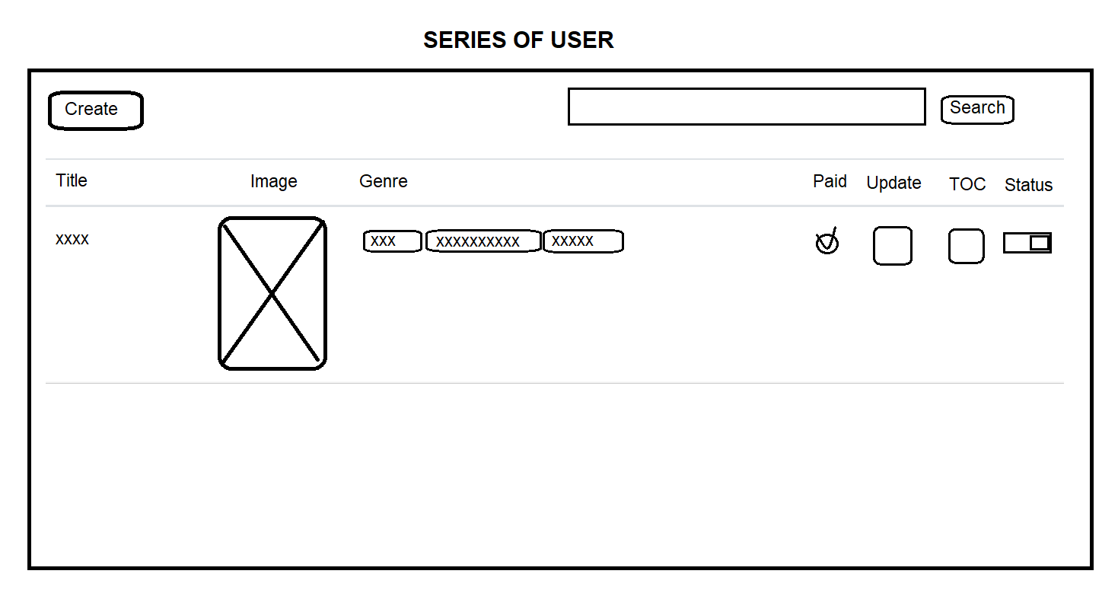
    - Button: Create, Update, TOC (Tables of Contents), Disable
    - Table includes Title, Image (default if no input), Genres, Paid Status
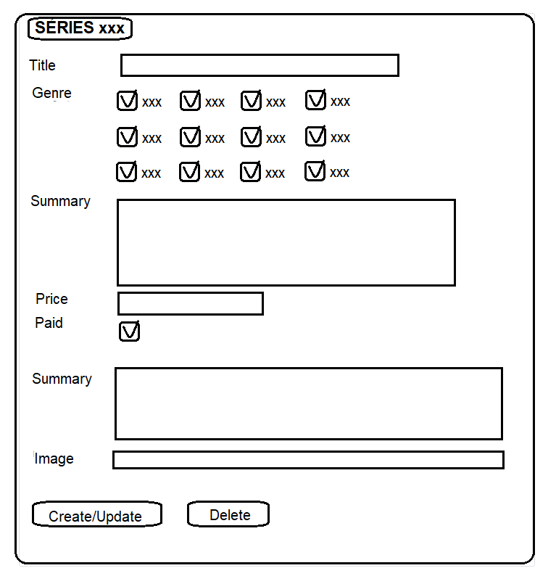
    - Button: Create/Update, Delete
Inputs field for Book’s information, if customer reaches access level 3, the field for Price and Paid status can be displayed and altered by himself

33. View List Author
- Function trigger: When admin click Author Management title or page button
- Function description
- Roles: Admin
- Purpose: let admin can see the list of authors below
- Function Detail:
- The screen will display the authors-generated and authors-users detail
- Paging with 10 authors each page

- Screen Layout: 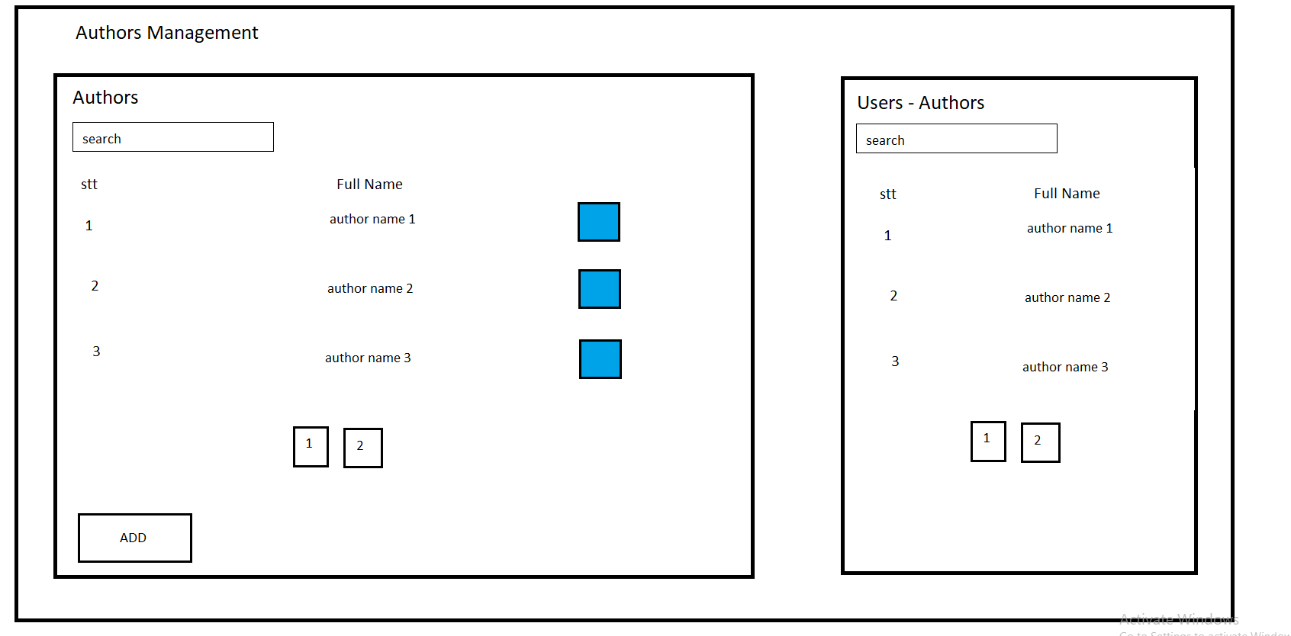

34 Edit Author
- Function trigger: When admin search , input new author name and click on button , click button “ADD”
- Function description
- Roles: Admin
- Purpose: let admin can adjust the list of authors below
- Function Detail:
- The screen will display the authors-generated and authors-users detail
- Each table has different search and will return the list after enter
- Input new name and click “button” on the right will update the new name for that author
- Click on the id of author will return a list of books belong to that author
- Click “Add” button send to AddBook page

Screen Layout: 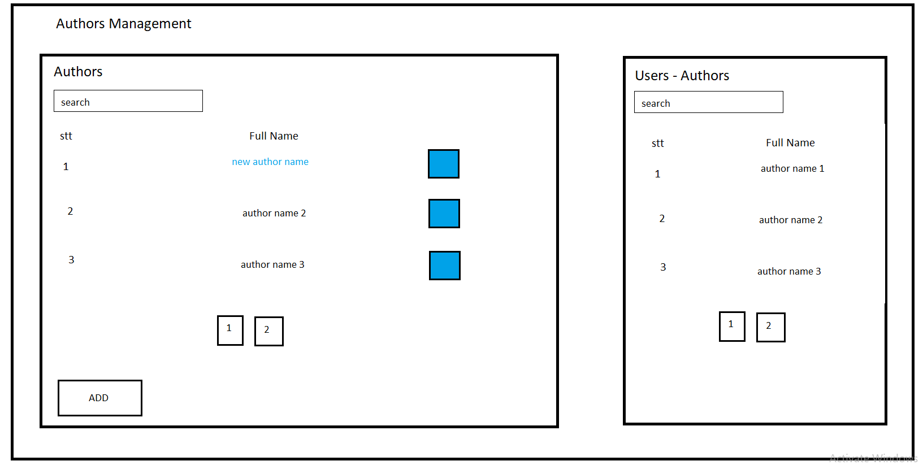

35 Admin Panel
- Function trigger: When admin Dashboard
- Function description
- Roles: Admin
- Purpose: let admin can data research
- Function Detail:
- The screen will display some features : total book , total comment , total
- Chart will display : the change of users approach per month , users approach per quarter in year , the amount of authors and users - authors

Screen Layout:
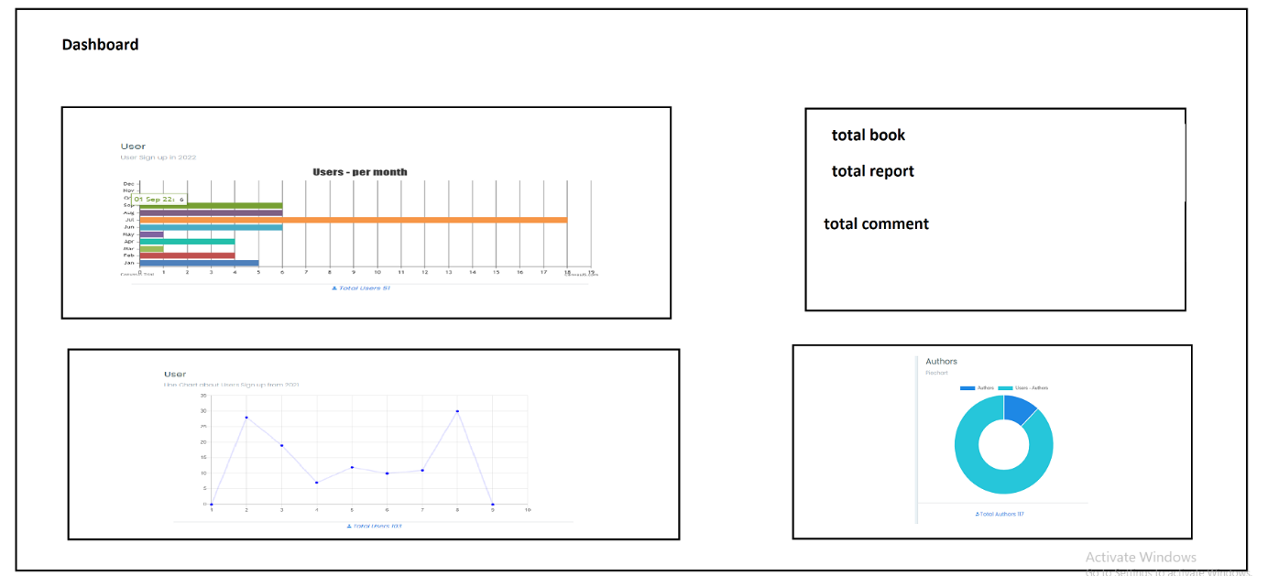

36 List book of this author
- Function trigger: User click on the book, it will automatically display list books of that author
- Function description:
  - Actor: Users
  - Purpose: See all book of a authors
  - Interface:
+ A logo to access homepage
+ A fixed Menu collapsed
+ A header named “From this author”
+ All books from the same author, 3 books per row
+ Contact interface
- Screen Layout

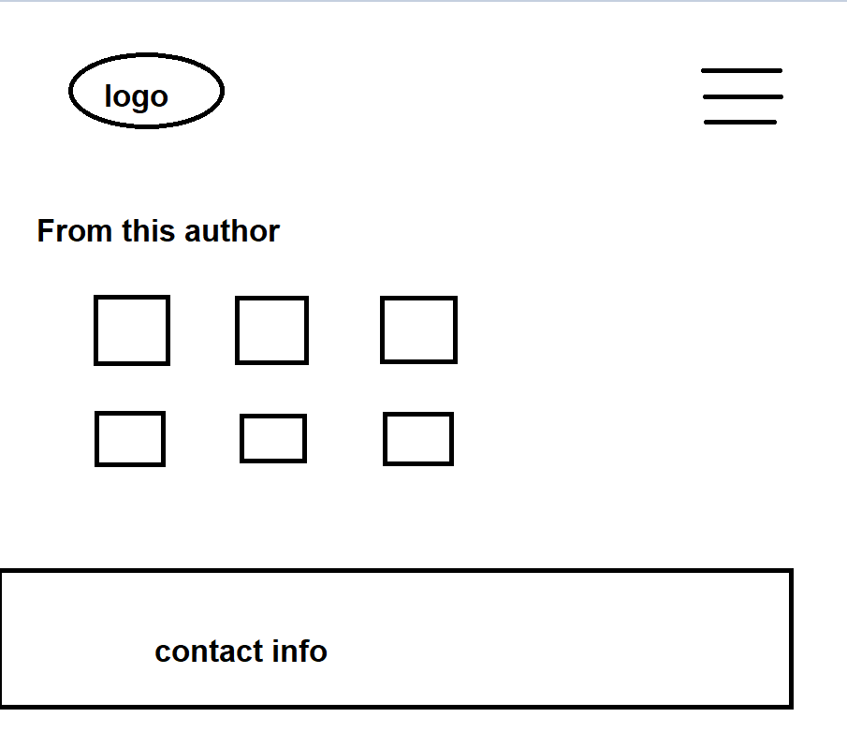

- Function details: When user clicks on author’s name, system redirects to a new page to display all book have same author that they have chose.

37 Add chapter for user’s novel
- Function trigger: User click on the “+” button, system will display the interface that user can add content for chapter.
- Function description:
  - Actor: Users
  - Purpose: Create a new chapter
  - Interface:
+ A logo to access homepage
+ A fixed Menu collapsed
+ A fixed User menu
+ A header “Series of” this book
+ A div tag that user use for adding new chapter. “Title” and “Content” are in text-form, Status is in option-form. All field is required.

- Screen Layout

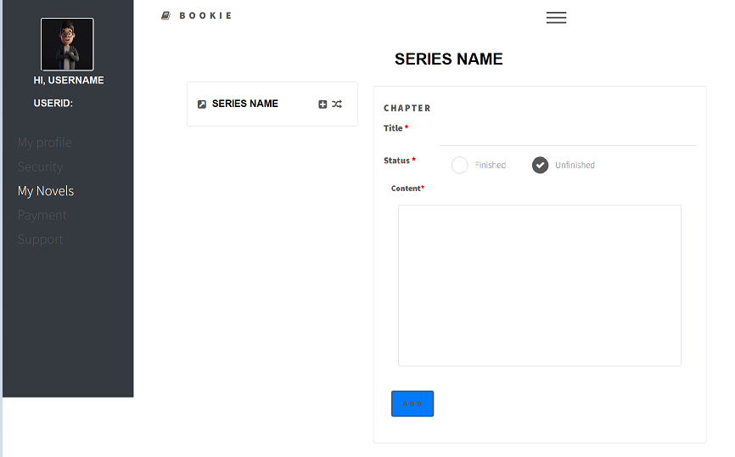
Before creating

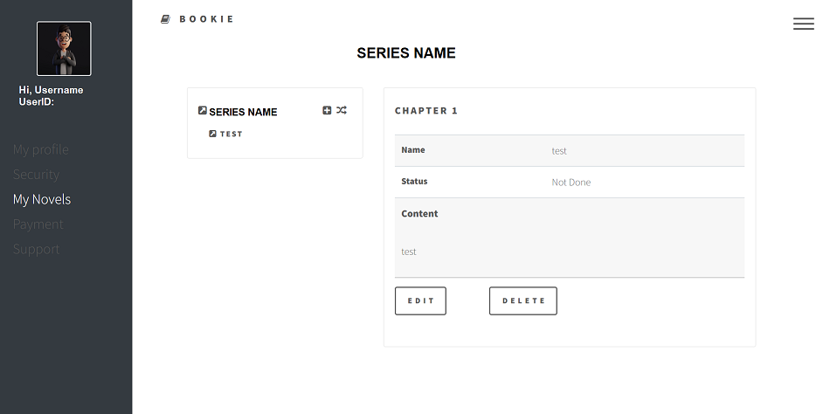
After creating

- Function details: When user clicks on “Add” button, the create chapter interface appear. After fill in all field of the dialog, the dialog is change to disable mode and appear to button are “Edit” and “Delete”.

38 Edit chapter for user’s novel
- Function trigger: User click on name of the chapter, system will display interface contains information chapter
- Function description:
  - Actor: Users
  - Purpose: Changing information of chapter
  - Interface:
+ A logo to access homepage
+ A fixed Menu collapsed
+ A fixed User menu
+ A header “Series of” this book
+ A div tag that display information of chapter, contains chapter’s name, status, and content, in disable mode
+ Two buttons “Edit” and “Delete”
- Screen Layout:

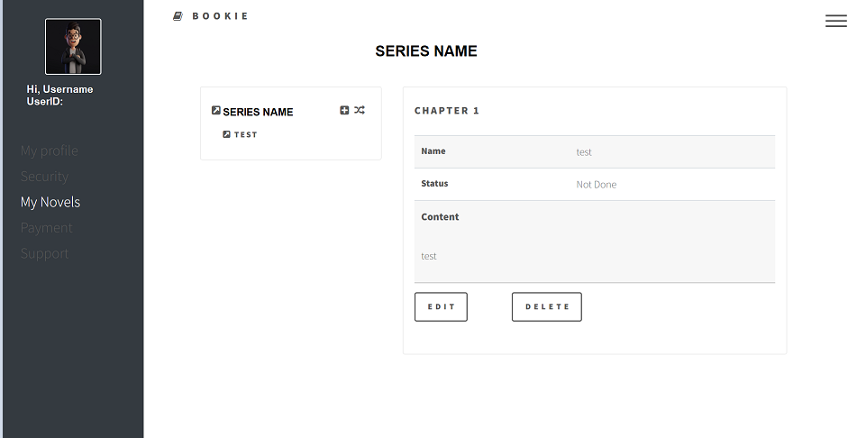

Function details: User clicks on name of the chapter, the dialog appear with two options “Edit’ and “Delete”. All fields are in disable mode. User click on “Edit” to change information of chapter. After choosing “Edit”, all fields are allowed to edit. To finish work, user re-click on “Edit” button and then all fields are back to disable mode.

39 Delete chapter for user’s novel
- Function trigger: User click on name of the chapter, system will display interface contains information chapter
- Function description:
  - Actor: Users
  - Purpose: Delete chapter
  - Interface:
+ A logo to access homepage
+ A fixed Menu collapsed
+ A fixed User menu
+ A div tag contains book’s name, option add chapter and back to book-detail page.
+ A div tag that display information of chapter, contains chapter’s name, status, and content, in disable mode
+ Two buttons “Edit” and “Delete”
- Alert screen
+ Message confirm decision
+ Two buttons “Close” and “Delete”
- Screen Layout:

System interface

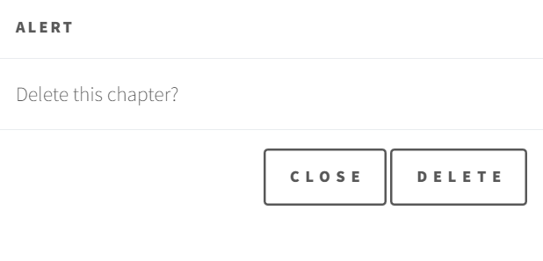
Alert screen
Function details: User clicks on name of the chapter, the dialog appear with two options “Edit’ and “Delete”. All fields are in disable mode. User click on “Delete” to remove chapter. After choosing “Delete”, a message warning displayed. User click on “Delete” to confirm, or “Close” to recall decision

40 Category Management
a. View
- Function trigger: This use case starts when user click on “Category management” on left side bar in profile srceen.
- Function description:
  - Role: Admin
  - Purpose: View list of categories
- Function layout:
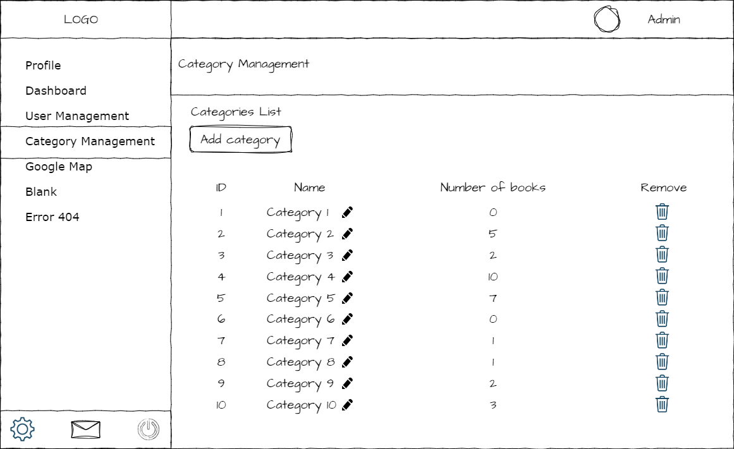
- Function detail:
  - Admin can see all of categories and how many books in each category.
  - From here, user can edit category name, delete category or add new category

b. Remove
- Function trigger: This use case starts when user click on garbage can icon in the line of category that he want to remove
- Function description:
  - Role: Admin
  - Purpose: Remove a category
- Function layout:
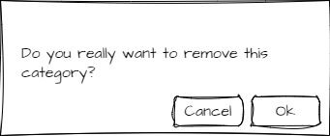
- Function detail:
  - When user click on remove button, a pop-up appear to confirm his request.
  - If user confirm, remove this category. Otherwise, close pop-up without any change
c. Update
- Function trigger: This use case starts when user click on pen icon next to category’s name
- Function description:
  - Role: Admin
  - Purpose: Rename category
- Function layout:
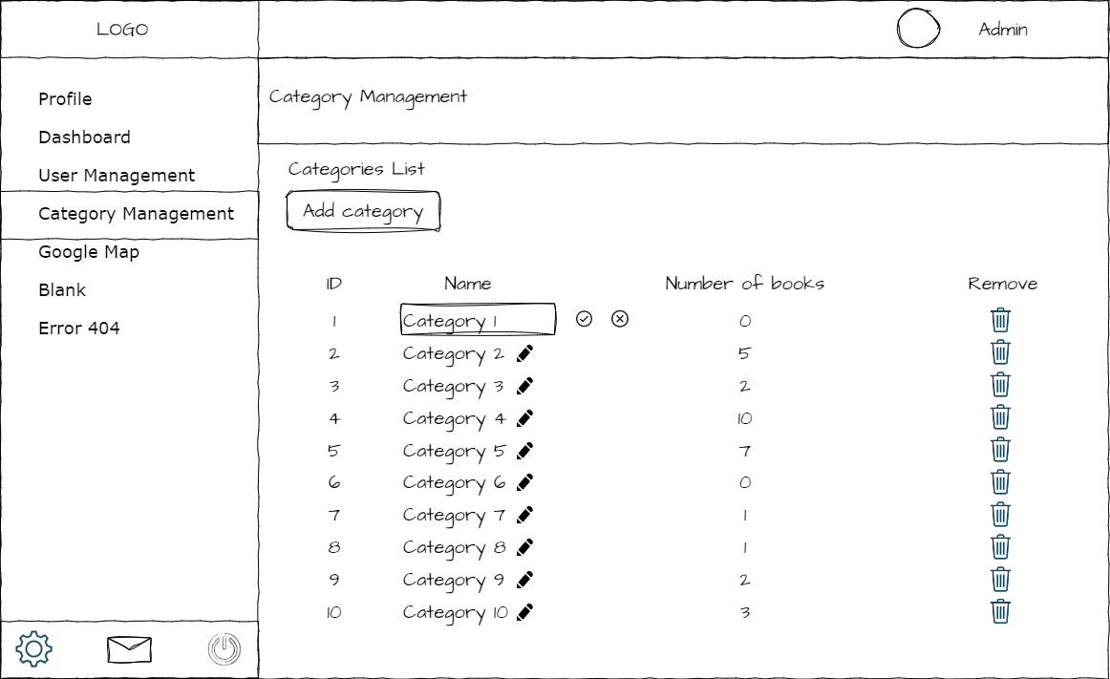
- Function detail:
  - When user click on update button, this button is replace by “Save” and “Discard” button and category name field become an input field.
  - After enter new category name, if user click “Save”, category name will be update. Otherwise, back to normal category view without any change.

d. Add
- Function trigger: This use case starts when user click on “Add category” button above the table of categories.
- Function description:
  - Role: Admin
  - Purpose: Add new category
  - Interface: Popup
    - 1 text field to enter new category name
    - 2 button to choose add or cancel
- Function layout:
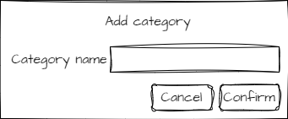
- Function detail:
  - Admin can enter new category name and click on “confirm” button to add new category.
  - If admin don’t want to add new category anymore, click on “cancel” button.
  - Show message if this action success.

41 Bookshelf
- Function trigger: This use case starts when user click on “Bookshelf” from right menu.
- Function description:
  - Role: User
  - Purpose: Show all books of this user, include bought books, favorite books and creations
- Function layout:
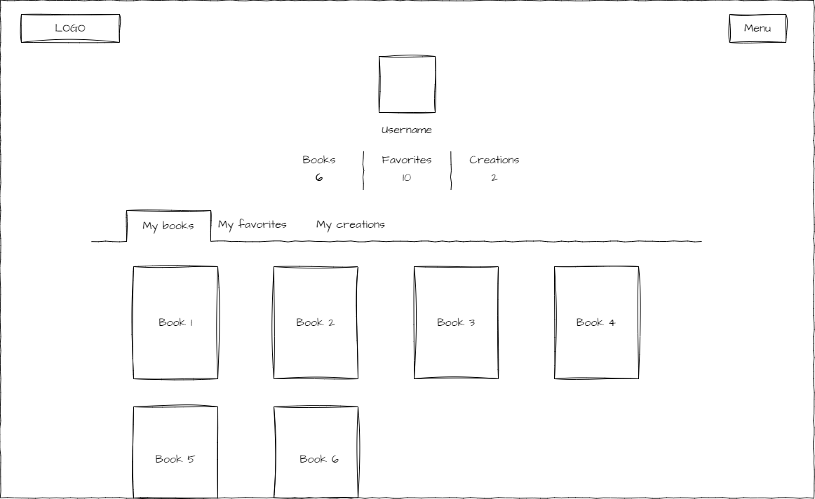
- Function detail:
  - User can see how many books he bought, he added to favorite or he wrote.
  - When click on tab “My books”, user sees all of books that he bought.
  - When click on “My favorites”, user sees all of books that he added to favorite.
When click on “My creations”, user sees all of books that he wrote

